## Ansible

### Case study assignment



Solution:

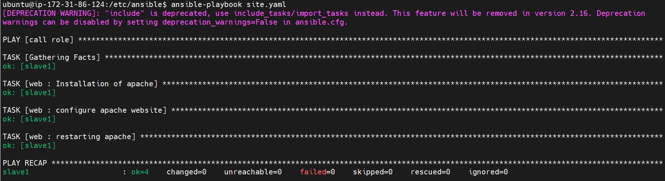

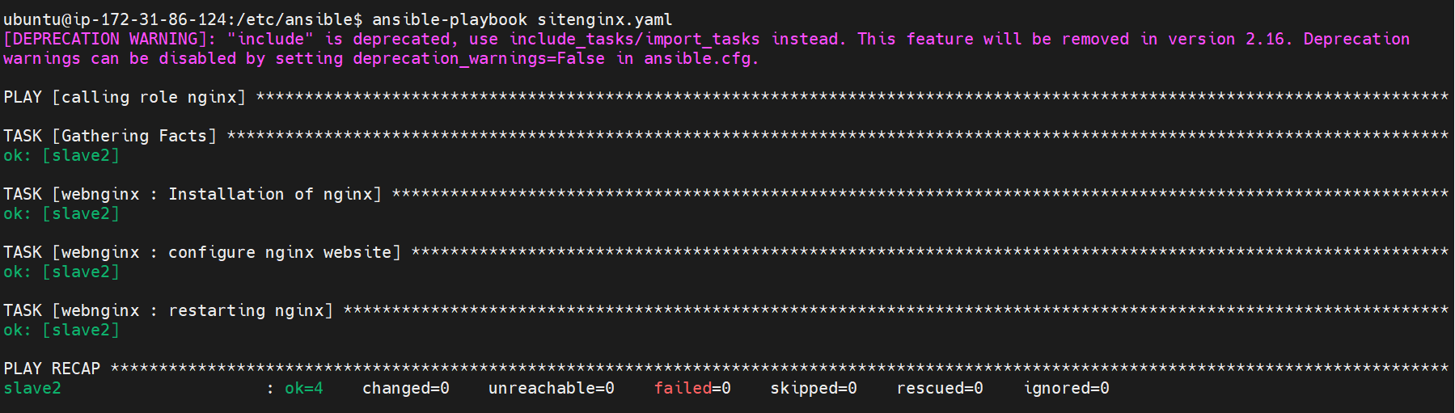

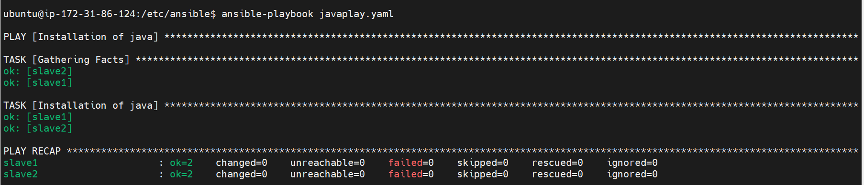





Github repository: <https://github.com/saaritssinha/Casestudy_ansible>